What's in it for me?
In this course you will explore how to successfully build streaming data pipelines in order to solve a real business problem using Google Cloud products. You will learn about various different pipeline architectures and the building blocks that enable them from expert presentations and demonstrations, and then apply that knowledge to a real-world use case.
Click the play button to watch the video.

Play Video
This video introduces the Build Streaming Data Pipelines on Google Cloud, and the products you'll learn about in the course.
By the end of this course, you will be able to:

✓ Ingest and manage streaming data using powerful messaging services like Pub/Sub and Managed Service for Apache Kafka.
✓ Build and deploy scalable streaming data pipelines with Dataflow and it's underlying Apache Beam framework.
✓ Implement effective streaming data solutions for both real-time analytics and application serving with BigQuery and Bigtable.

The use case

About the company
Cymbal Gaming is a pioneering force in real-time data orchestration for the high-stakes world of competitive gaming. Unlike traditional data platforms, Cymbal Gaming specializes in developing and deploying ultra-low-latency streaming data pipelines specifically designed to capture, process, and analyze the immense torrent of data generated during live e-sports events and fast-paced player-vs-player gaming. Their platform is engineered to handle billions of real-time events per second from player actions, player-to-player interactions, and in-game statistics, to audience engagement metrics and broadcast telemetry.

Your role
At Cymbal Gaming you aren't just a streaming data engineer, you're the visionary architect responsible for crafting real-time insights that directly fuel the high-stakes world of e-sports live races and heads-up game play. Your team's mission is to support the globally beloved sensation, the "Galactic Grand Prix". To do this, you need to design robust pipelines that must be capable of ingesting terabytes of live simulator data, scale secure, low-latency infrastructure across continents, and transform raw output into actionable intelligence—all in real time.

Cymbal Gaming's Galactic Grand Prix
This video introduces the core use case for this course: Cymbal Gaming, the fictional data engineering company that designs and implements streaming data pipelines. You'll explore their partnership with the Galactic Grand Prix, a global gaming sensation. Through this collaboration, you'll learn how to build real-time data solutions that power both large-scale live tournaments and individual heads-up game play, ensuring a seamless and responsive experience for competitors and spectators alike.
Click the play button to watch the video.

Play Video
This video introduces Cymbal Gaming, the fictional data engineering company used throughout this course, as well as the global gaming sensation they support, the Galactic Grand Prix.

The challenge
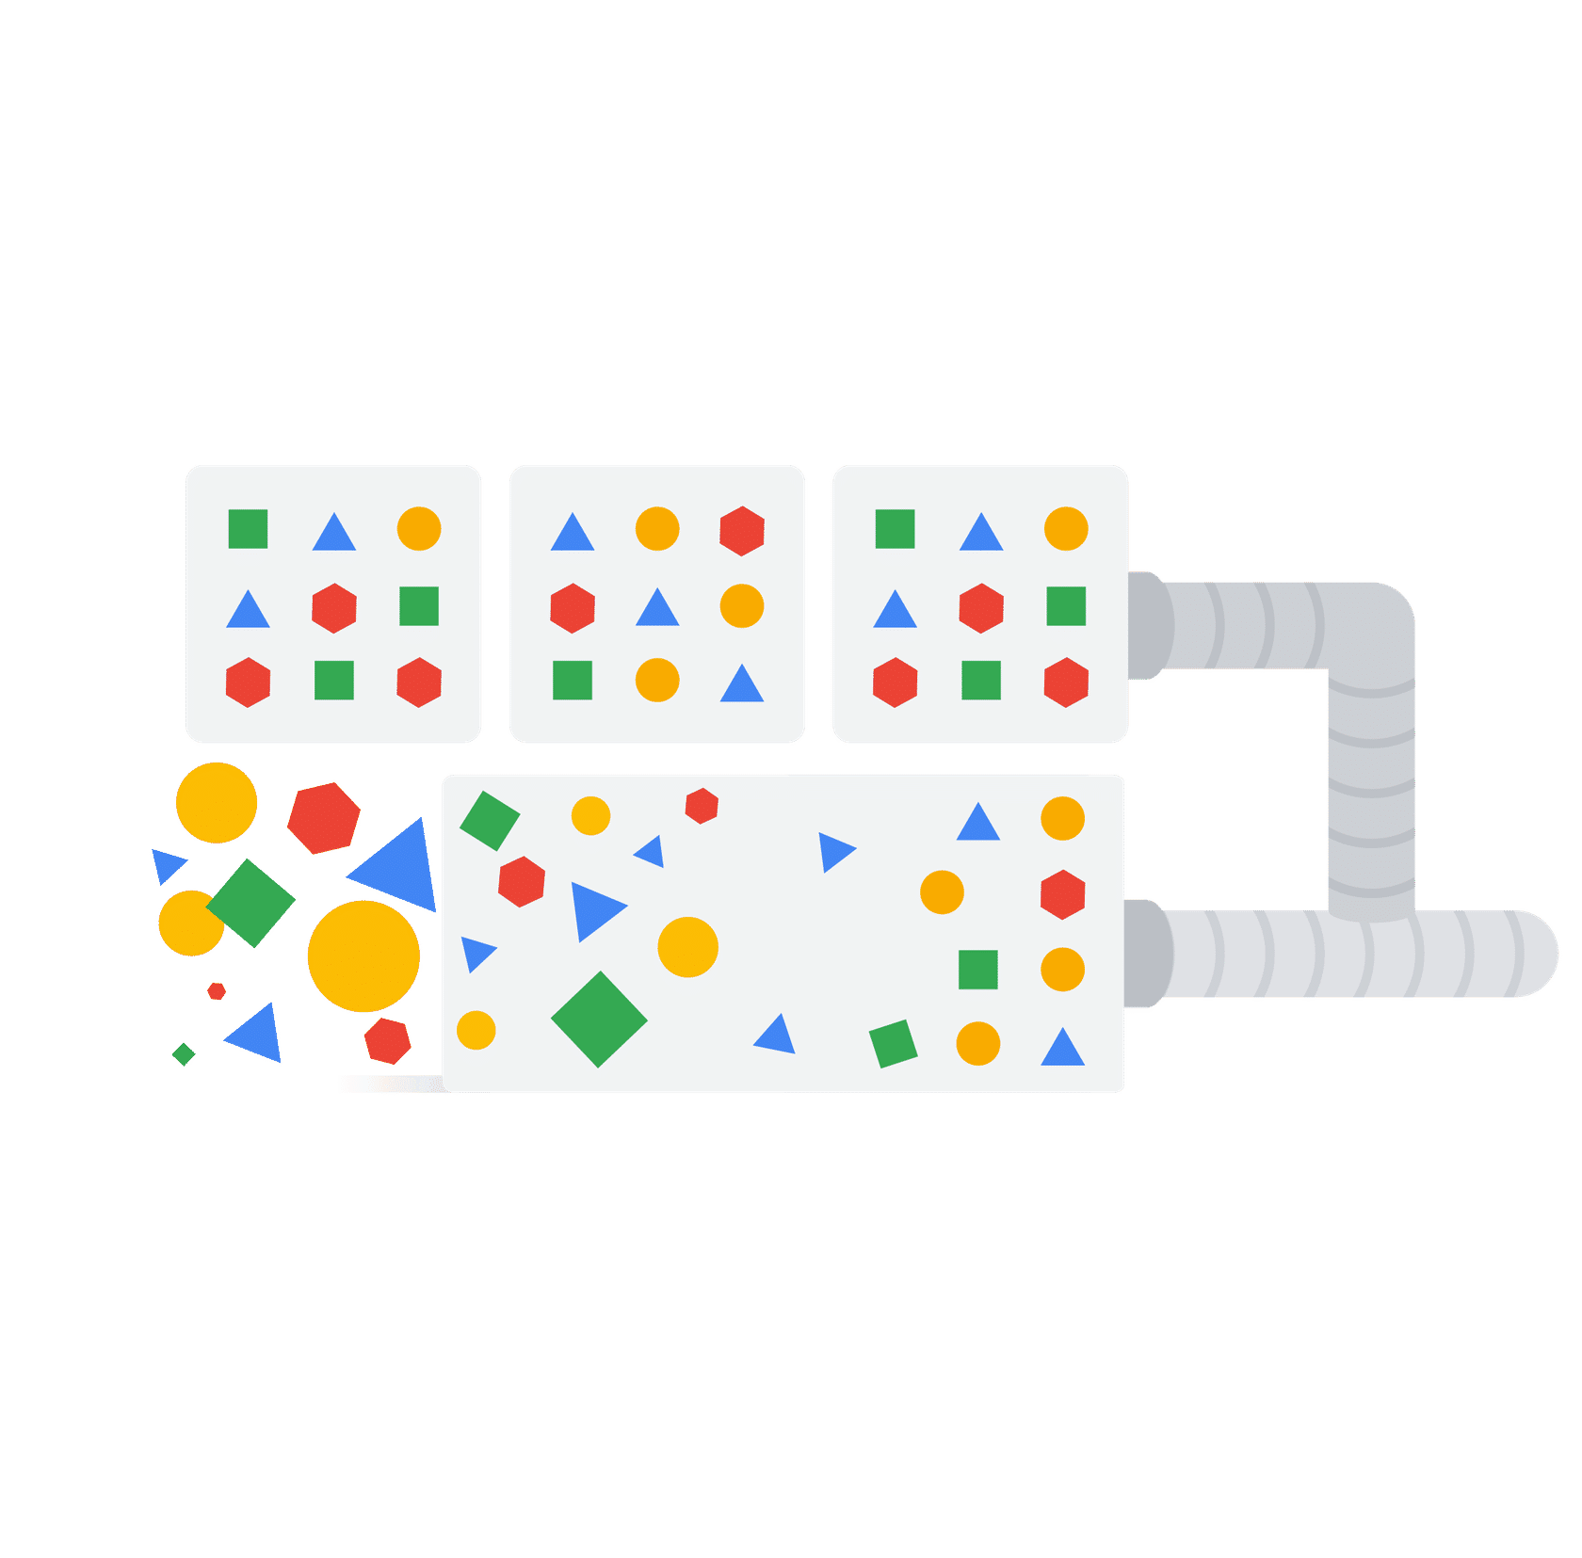
This image represents an abstraction of fast-paced real-time data.
In the fast-paced world of e-sports, data needs to be acted upon instantly. Traditional batch processing where data is collected and processed in large chunks at set intervals isn't ideal. Every millisecond counts as the platform needs to handle billions of live events per second, from player-to-player actions and live in-game statistics to audience engagement metrics and broadcast telemetry.
Click each button to learn more about the challenges common to real-world streaming pipelines.

High velocity and volume
Billions of events generated per second, requiring systems that can keep up without falling behind.

Low latency requirements
Insights and actions must be derived within milliseconds or seconds, not minutes or hours.

Data quality and order
Ensuring data integrity, completeness, and correct ordering in a continuous stream can be complex.

Scalability and elasticity
Pipelines must automatically scale up or down to handle fluctuating data loads, especially in dynamic events like a global tournament.

Fault tolerance and durability
Systems must be resilient to failures and ensure no data is lost during processing.

The mission
To successfully navigate these challenges and support the Galactic Grand Prix you understand that victory isn't just about skill, it's about data. You believe Google Cloud products like Pub/Sub, Managed Service for Apache Kafka

